**Linking the performance of a data-limited empirical catch rule to life-history traits**

Simon H. Fischer, José A. A. De Oliveira, Laurence T. Kell

**Supplementary Material**

Part 1: Operating model description (page 1)

Part 2: Sensitivity analysis of operating model assumptions (page 7)

# Part 1: Operating model description

Age structured operating models for the 29 simulated stocks were created using the Fisheries Library in R (FLR, Kell *et al.*, 2007) package FLife (<https://github.com/flr/FLife>). The source code for the creation of the operating models and the management strategy evaluation is available on GitHub at <https://github.com/shfischer/wklifeVII>.

Input parameters used were the allometric length-weight parameters (, ), von Bertalanffy growth parameters , and , and the length or age at 50% maturity (, ). These input values are given in Table S1. Table S2 gives further parameters characterising the operating models of the 29 simulated stocks.

Missing input parameters can be estimated by FLife using empirical relationships; namely

(S1)

(Gislason *et al.*, 2008) and

(S2)

(Gislason *et al.*, 2008). However, in the present study, both equations S1 and S2 have never been applied because empirical estimates were available for both parameters for each simulated stock.

## Growth

Growth was modelled with the von Bertalanffy growth equation

(S3)

with . For , a default value of was used when not otherwise available, and the maximum age  (set as the plus-group) was defined as the age, rounded up, where growth reaches 95% of . This is calculated by solving the von Bertalanffy equation for and setting :

(S4)

After this initial modelling of growth as length, the operating model was built with an age structure, and only the lengths corresponding to the ages of the operating model were used subsequently.

## Natural morality

Natural mortality was modelled as length dependent according to equation 2 in Gislason *et al.* (2010):

(S5)

To derive natural mortality at age, the von Bertalanffy growth equation (S3) is substituted into equation S5.

## Maturity

Maturity at age is modelled with a sigmoid function:

(S6)

with (maximum maturity value) and (steepness of maturity curve).

## Selectivity

Fisheries selectivity at age is modelled with a flexible double normal function where the first age with full selectivity is set to :

(S7)

and . The selection pattern was set to an asymptotic selectivity pattern by setting and

## Recruitment

Recruitment () is modelled with the Beverton-Holt stock recruitment

(S8)

Reformulated in terms of steepness (the proportion of expected recruitment produced at 20% virgin spawning-stock biomass, , relative to virgin recruitment, ), this gives

(S9)

The steepness was set to for all stocks to = 0.75 and arbitrarily to 1000.

## Population dynamics

Population dynamics follow the usual exponential decay equations:

(S10)

(S11)

where .

## Observations

### Catch length distribution

The catch length distribution was derived from the catch at age distribution from the operating model by applying an inverse age-length key.

The inverse age-length key was based on the von Bertalanffy growth curve and uncertainty around the length at age was added by applying a normal distribution on the expected length at age.

To do this, length at age () was first calculated based on the catch weight at age () from the operating model with the length weight relationship parameters (, ) and the allometric length weight relationship:

(S12)

(S13)

This approach using equations S12 and S13 leads to lengths that were mathematically identical to the lengths from the von Bertalanffy growth model (equations S3) because weights at age in the operating model were calculated with the same von Bertalanffy growth model and parameters and then converting length to weight with the allometric length-weight parameters.

The simulated stocks are data-limited and there are no generic length-at-age distributions easily available to model length distributions. Therefore, in order to simulate a probabilistic inverse age length key, the (deterministic) lengths at age were spread with a normal distribution and a discrete length distribution generated for each age:

(S14)

With and . Each contained lengths rounded to the nearest cm and was cut off:

(S15)

and

(S16)

The result of this approach was a probabilistic inverse age-length key with length probabilities for each age of the operating model. The possible length probabilities at age from this key were standardised subsequently. This inverse length-key was then applied to the catch at age distribution to derive the length distribution of the catch.

Sampling from the length distribution (for the management procedure) was approximated by including a log-normal error term with a distribution (in log space) of with and , where is the catch at length, in 1cm length bins. This was considered appropriate because the management procedure uses only the mean length in the catch above (where is defined as the first length class where the catch is at or above half the mode of the distribution of catch numbers) and a comparison of mean lengths derived from our approximation and sampling of the catch length frequencies resulted in very similar lengths (both in terms of median as well as uncertainty). Furthermore, this approach substantially reduced the runtime and computational requirements of the simulation.

### Biomass index

A biomass index was created with selectivity based on a logistic function:

(S17)

with (maximum selectivity), (steepness of selectivity curve) and (inflection point of selectivity curve).

The final biomass index, as observed by the management procedure was aggregated over all ages:

(S18)

Where the log-normal error term has a distribution in log-space of and is added to the age aggregated biomass index.

### Additional uncertainty

Additional uncertainty was implemented for life-history parameters with the log-normal error terms having a distribution in log-space of which were used, for example, in the calculation of the length reference point . No additional uncertainty was added to the biomass index reference point , because this value was calculated from the observed index which already included the observation error.

## References

Gislason, H., Daan, N., Rice, J. C., and Pope, J. G. 2010. Size, growth, temperature and the natural mortality of marine fish. Fish and Fisheries, 11: 149–158.

Gislason, H., Pope, J. G., Rice, J. C., and Daan, N. 2008. Coexistence in North Sea fish communities: implications for growth and natural mortality. ICES Journal of Marine Science, 65: 514–530.

Kell, L. T., Mosqueira, I., Grosjean, P., Fromentin, J.-M., Garcia, D., Hillary, R., Jardim, E., *et al.* 2007. FLR: an open-source framework for the evaluation and development of management strategies. ICES Journal of Marine Science, 64: 640–646.

**Table S1.** The 29 stocks used in the simulation and their scientific and common names, ICES ecoregion where the life-history parameters are sourced from, a unique stock ID, sex (male M, female F, combined C) and the life-history parameters used as input for the operating models; von Bertalanffy growth equation parameters (, , ), length-weight parameters (, ), and length and age at 50% maturity (, ).

|  |  |  |  |  |  |  |  |  |  |  |  |
| --- | --- | --- | --- | --- | --- | --- | --- | --- | --- | --- | --- |
| **Scientific name** | **Common name** | **ICES ecoregion** | **ID** | **sex** | [year-1] | [cm] | [years] |  |  | [cm] | [years] |
| *Lophius budegassa* | blackbellied angler | Celtic Sea | ang3 | F | 0.08 | 110.1 | 0.39 | 0.0259 | 2.858 | 54.8 | 9 |
| *Raja clavata* | thornback ray | North Sea | rjc | F | 0.09 | 118 | -0.88 | 0.0045 | 3.0686 | 77.1 | 6.69** |
| *Anarchias lupus* | Atlantic wolffish | North Sea | wlf | F | 0.11 | 115.1 | -0.39 | 0.0046 | 3.185 | 21.5 | 3.8 |
| *Sebastes norvegicus* | golden redfish | Northern | smn | C | 0.11 | 50.2 | 0.08 | 0.0178 | 2.972 | 40.3 | 14.84** |
| *Lepidorhombus whiffiagonis* | megrim | North Sea | meg | C | 0.12 | 54 | -0.1* | 0.0022 | 3.3433 | 23 | 3 |
| *Molva molva* | ling | Widely | lin | C | 0.14 | 119 | -0.1* | 0.0036 | 3.108 | 74 | 7.2 |
| *Raja clavata* | thornback ray | Celtic Sea | rjc2 | F | 0.14 | 139.5 | -1.84 | 0.0024 | 3.2653 | 71.8 | 6.13 |
| *Mustelus asterias* | starry smooth-hound | Widely | sdv | F | 0.15 | 123.5 | -0.1* | 0.001 | 3.27 | 81.9 | 7.15** |
| *Scyliorhinus canicula* | lesser spotted dogfish | Celtic Sea | syc | F | 0.15 | 75.14 | -0.96 | 0.0019 | 3.1541 | 57 | 7.9 |
| *Lophius piscatorius* | angler | Celtic Sea | ang | C | 0.18 | 105.555 | -0.38 | 0.0198 | 2.895 | 73 | 6.16** |
| *Lophius piscatorius* | angler | North Sea | ang2 | C | 0.18 | 106 | -0.1* | 0.0297 | 2.841 | 61 | 4.66* |
| *Pollachius pollachius* | pollack | North Sea | pol | C | 0.19 | 85.6 | -0.1* | 0.0076 | 3.069 | 47.1 | 4.11** |
| *Melanogrammus aeglefinus* | haddock | Celtic Sea | had | C | 0.2 | 79.9 | -0.36 | 0.0113 | 2.96 |  | 2 |
| *Nephrops* | Norway lobster | Biscay-Iberia | nep | M | 0.2 | 70 | -0.1* | 0.00028 | 3.229 | 28.4 | 2.50** |
| *Mullus surmuletus* | striped red mullet | Celtic Sea | mut | F | 0.21 | 47.5 | -0.1* | 0.0057 | 3.243 | 16.9 | 1.99** |
| *Spondyliosoma cantharus* | black seabream | Celtic Sea | sbb | F | 0.22 | 41.25 | -1.16 | 0.0148 | 3.004 | 22 | 2.30** |
| *Argentina silus* | greater argentine | Widely | arg | C | 0.23 | 44 | -0.1* | 0.005 | 3.075 | 38 | 8.2 |
| *Pleuronectes platessa* | European plaice | Celtic Sea | ple | F | 0.23 | 48 | -0.1* | 0.011 | 2.958 | 22.9 | 2.72** |
| *Scyliorhinus canicula* | lesser spotted dogfish | Biscay-Iberia | syc2 | F | 0.23 | 66.2 | -0.71 | 0.0022 | 3.119 | 59.1 | 9.00** |
| *Chelidonichtys lucerna* | tub gurnard | Celtic Sea | gut | F | 0.32 | 66.8 | -0.46 | 0.0043 | 3.21 | 40.1 | 2.41** |
| *Scopthalmus maximus* | turbot | North Sea | tur | F | 0.32 | 66.7 | 0.29 | 0.0149 | 3.079 | 34.2 | 2.2 |
| *Merlangius merlangus* | whiting | Celtic Sea | whg | F | 0.38 | 38 | -1.01 | 0.0103 | 2.395 | 28 | 2.50** |
| *Scophthalmus rhombus* | brill | North Sea | bll | F | 0.38 | 58 | -0.27 | 0.014 | 3.01 | 31.3 | 1.6 |
| *Microstomus kitt* | lemon sole | North Sea | lem | C | 0.42 | 37 | -0.1* | 0.0123 | 2.971 | 27 | 3.02** |
| *Engraulis encrasicolus* | anchovy | Biscay-Iberia | ane | C | 0.44 | 23 | -0.1* | 0.005 | 3.107 | 16.8 | 2.88** |
| *Zeus faber* | John Dory | Celtic Sea | jnd | F | 0.47 | 50.8 | -1.47 | 0.0399 | 2.754 | 34.5 | 0.95** |
| *Sardina pilchardus* | European pilchard | Celtic Sea | sar | C | 0.6 | 22 | -0.1* | 0.0053 | 3.162 | 14.3 | 1.65** |
| *Clupea harengus* | herring | Celtic Sea | her | F | 0.606 | 33 | -0.1* | 0.0048 | 3.198 | 23 | 1.87** |
| *Ammodytes spp.* | sandeels | North Sea | san | C | 1 | 24 | -0.1* | 0.0049 | 2.783 | 12 | 0.59** |

* Denotes where default values for have been used.

** These values were calculated with the von Bertalanffy growth equation parameters and .

**Table S2.** Further operating model values for the 29 simulated stocks. The stock ID corresponds to the ID in Table S1. Shown are the maximum age (plus-group ), age range for mean fishing mortality (minfbar, maxfbar), Beverton-Holt stock-recruitment parameters (*α*, *β*), spawners per recruit at F=0 (*SPR0*), MSY reference points (*FMSY*, *MSY*, *BMSY*, mean length at MSY: *Lopt*), growth rate (instantaneous growth rate at the limit of zero stock size *g*, and conditional growth rate at MSY *gc,* both derived from a Leslie matrix model), mean natural mortality of the mature proportion of the stock (*M*), and the ratios *M*/*k* (von Bertalanffy *k*), *FMSY*/*M* and *BMSY*/*SSB0* (virgin SSB, 1000 for all stocks).

|  |  |  |  |  |  |  |  |  |  |  |  |  |  |  |  |  |
| --- | --- | --- | --- | --- | --- | --- | --- | --- | --- | --- | --- | --- | --- | --- | --- | --- |
| **ID** |  | **minfbar** | **maxfbar** | ***α*** | ***β*** | ***SPR0*** | ***FMSY*** | ***MSY*** | ***BMSY*** | ***Lopt*** | ***g*** | ***gc*** | ***M*** | ***M/k*** | ***FMSY/M*** | ***BMSY/SSB0*** |
| ang3 | 38 | 4 | 20 | 14.22 | 90.91 | 76.71 | 0.06 | 22.08 | 275.28 | 109.00 | 0.13 | 0.05 | 0.09 | 1.15 | 0.65 | 0.28 |
| rjc | 21 | 2 | 13 | 0.31 | 90.91 | 3515.48 | 0.10 | 45.76 | 250.00 | 83.96 | 0.22 | 0.09 | 0.14 | 1.02 | 0.70 | 0.25 |
| wlf | 27 | 1 | 10 | 0.44 | 90.91 | 2489.95 | 0.07 | 27.75 | 282.61 | 82.22 | 0.25 | 0.09 | 0.15 | 1.36 | 0.49 | 0.28 |
| smn | 28 | 9 | 23 | 52.76 | 90.91 | 20.68 | 0.11 | 51.59 | 227.85 | 49.70 | 0.12 | 0.06 | 0.12 | 1.07 | 0.91 | 0.23 |
| meg | 25 | 1 | 5 | 17.51 | 90.91 | 62.30 | 0.08 | 25.43 | 323.66 | 35.88 | 0.25 | 0.07 | 0.18 | 1.54 | 0.42 | 0.32 |
| lin | 22 | 2 | 15 | 1.03 | 90.91 | 1061.06 | 0.09 | 40.86 | 263.18 | 85.71 | 0.19 | 0.08 | 0.14 | 1.01 | 0.67 | 0.26 |
| rjc2 | 32 | 2 | 15 | 0.07 | 90.91 | 14697.76 | 0.06 | 21.94 | 287.85 | 102.81 | 0.16 | 0.05 | 0.10 | 1.09 | 0.61 | 0.29 |
| sdv | 20 | 2 | 11 | 1.39 | 90.91 | 782.43 | 0.09 | 42.97 | 265.69 | 91.96 | 0.19 | 0.08 | 0.15 | 0.99 | 0.59 | 0.27 |
| syc | 20 | 3 | 13 | 2.74 | 90.91 | 398.58 | 0.12 | 60.23 | 234.23 | 52.37 | 0.22 | 0.10 | 0.16 | 1.04 | 0.74 | 0.23 |
| ang | 17 | 1 | 9 | 0.35 | 90.91 | 3084.69 | 0.10 | 58.02 | 251.17 | 72.08 | 0.24 | 0.10 | 0.18 | 0.99 | 0.59 | 0.25 |
| ang2 | 17 | 1 | 8 | 0.41 | 90.91 | 2677.30 | 0.12 | 58.29 | 249.22 | 70.65 | 0.32 | 0.13 | 0.20 | 1.10 | 0.61 | 0.25 |
| pol | 16 | 1 | 6 | 1.18 | 90.91 | 927.67 | 0.12 | 48.29 | 284.13 | 58.74 | 0.30 | 0.11 | 0.21 | 1.12 | 0.54 | 0.28 |
| had | 15 | 1 | 5 | 0.83 | 90.91 | 1312.47 | 0.15 | 43.96 | 310.45 | 52.55 | 0.42 | 0.13 | 0.26 | 1.30 | 0.58 | 0.31 |
| nep | 15 | 1 | 4 | 29.81 | 90.91 | 36.60 | 0.15 | 53.51 | 278.87 | 49.33 | 0.47 | 0.17 | 0.28 | 1.38 | 0.54 | 0.28 |
| mut | 15 | 1 | 5 | 5.78 | 90.91 | 188.70 | 0.20 | 83.72 | 231.43 | 31.22 | 1.04 | 0.40 | 0.35 | 1.66 | 0.59 | 0.23 |
| sbb | 13 | 1 | 5 | 2.14 | 90.91 | 509.71 | 0.22 | 74.92 | 256.33 | 24.73 | 0.55 | 0.21 | 0.28 | 1.29 | 0.77 | 0.26 |
| arg | 13 | 3 | 11 | 36.11 | 90.91 | 30.21 | 0.16 | 116.74 | 220.42 | 26.86 | 0.23 | 0.11 | 0.24 | 1.04 | 0.65 | 0.22 |
| ple | 13 | 1 | 5 | 7.57 | 90.91 | 144.02 | 0.21 | 90.74 | 234.03 | 29.31 | 0.64 | 0.27 | 0.32 | 1.40 | 0.65 | 0.23 |
| syc2 | 13 | 4 | 11 | 6.96 | 90.91 | 156.77 | 0.15 | 122.34 | 212.04 | 43.79 | 0.24 | 0.13 | 0.22 | 0.96 | 0.69 | 0.21 |
| gut | 9 | 1 | 5 | 0.96 | 90.91 | 1130.63 | 0.26 | 100.71 | 256.06 | 44.72 | 0.65 | 0.26 | 0.37 | 1.15 | 0.71 | 0.26 |
| tur | 10 | 1 | 3 | 1.68 | 90.91 | 651.13 | 0.23 | 75.03 | 293.59 | 66.03 | 0.59 | 0.21 | 0.40 | 1.25 | 0.57 | 0.29 |
| whg | 7 | 1 | 4 | 32.98 | 90.91 | 33.08 | 0.39 | 209.17 | 211.60 | 20.30 | 0.85 | 0.41 | 0.44 | 1.15 | 0.90 | 0.21 |
| bll | 8 | 1 | 4 | 1.07 | 90.91 | 1021.82 | 0.40 | 143.51 | 235.34 | 41.26 | 1.23 | 0.51 | 0.48 | 1.27 | 0.84 | 0.24 |
| lem | 8 | 1 | 4 | 11.49 | 90.91 | 94.91 | 0.30 | 143.99 | 249.78 | 21.68 | 0.55 | 0.23 | 0.46 | 1.10 | 0.65 | 0.25 |
| ane | 7 | 1 | 4 | 95.92 | 90.91 | 11.37 | 0.40 | 331.09 | 195.77 | 13.87 | 1.11 | 0.61 | 0.57 | 1.30 | 0.69 | 0.20 |
| jnd | 5 | 1 | 3 | 0.59 | 90.91 | 1853.54 | 0.60 | 243.49 | 216.83 | 34.89 | 1.99 | 0.97 | 0.52 | 1.11 | 1.15 | 0.22 |
| sar | 5 | 1 | 3 | 51.17 | 90.91 | 21.32 | 0.76 | 372.20 | 202.48 | 15.76 | 2.04 | 1.08 | 0.81 | 1.35 | 0.94 | 0.20 |
| her | 5 | 1 | 3 | 12.99 | 90.91 | 83.98 | 0.64 | 402.75 | 198.70 | 23.76 | 2.16 | 1.20 | 0.76 | 1.25 | 0.84 | 0.20 |
| san | 3 | 1 | 2 | 83.89 | 90.91 | 13.00 | 1.47 | 588.43 | 211.17 | 16.01 | 2.85 | 1.70 | 1.21 | 1.21 | 1.21 | 0.21 |

# Part 2: Sensitivity analysis of operating model assumptions

## Background

This part of the supplementary materials describes additional sensitivity analyses of the assumptions used to create the operating models and observations.

The recruitment in the operating model for all stocks was modelled with a Beverton-Holt stock recruitment model (see part 1 above and equations S8, S9). The steepness of the recruitment model was set to a fixed value of . Recruitment variability was implemented with a log-normal noise term with (in log-space). During the work, concerns were raised about whether it is appropriate to use a constant value for recruitment steepness and how this might affect results. Additional work was carried out to explore the impact of the recruitment assumptions, and also the influence of uncertainty in the indices for biomass and length-frequencies.

The default value for steepness of used in this study was adopted from a previous study by Jardim *et al.* (2015) who based their decision on Myers *et al.* (1999). This value (0.75) is a medium value from the range of estimates in Myers et *al*. (1999) and therefore is suitable for generic simulations. Myers *et al.* (1999) estimated e.g. averages of for Clupeidae, for Gadidae and for Pleuronectidae.

In empirical data, relationships between steepness and life-history parameters are scarce and notoriously difficult to estimate, and this is particularly the case for data-limited stocks for which usually no data or assessment exists on which to base estimates of steepness. The stocks simulated in the present study are based on life-history parameters from real stock units and are not simply averages for species. These stocks are data-limited and therefore no analytical assessments exist on which to base steepness, i.e. the steepness for these stocks is entirely unknown. Consequently, a generic medium value was adopted.

Myers et *al*. (1999) estimated for 57 species. We queried Fishbase (Froese and Pauly, 2019) and found median von Bertalanffy growth parameter values for 53 of these species (Figure S1). There does not appear to be any correlation between these two parameters.

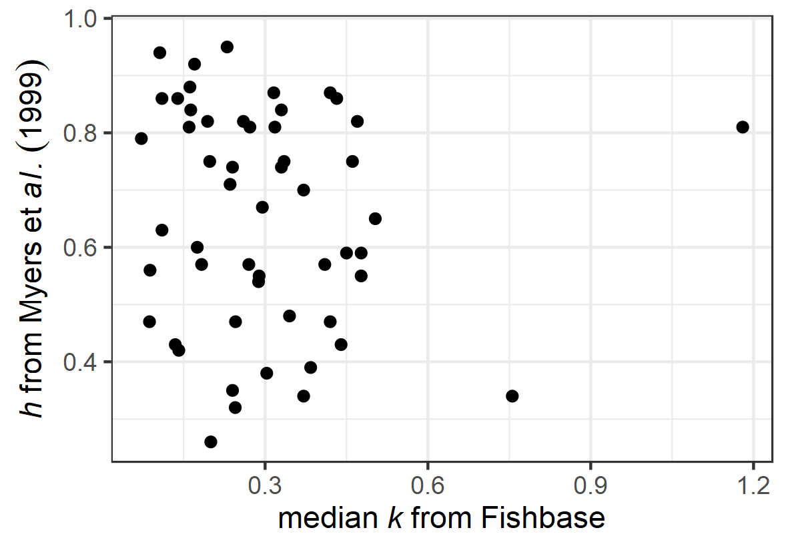

**Figure S1**. Steepness () as estimated by Myers et *al*. (1999) for 53 fish species versus von Bertalanffy growth parameter , queried from Fishbase (Froese and Pauly, 2019).

Wiff et *al*. (2018) screened fish stocks for a link between and life-history parameters, and found a logit-link relationship between and the ratio , but with high uncertainty and limited predictive power (see Figure 1 in Wiff et *al.*, 2018).

## Sensitivity runs

In order to test the sensitivity of the simulations to the imposed recruitment assumptions, additional sets of operating models (OM) with different assumptions about recruitment were created and the MSE simulation was repeated with them.

### Recruitment steepness

1. Steepness levels: low (), medium (; default for this study) and high (). In a Beverton-Holt recruitment model, steepness cannot go above , and was selected as the high value in order to avoid the absolute maximum. This high steepness value means that recruitment is only impaired at low SSB and is therefore largely decoupled from SSB. This corresponds to a 20% increase in steepness, and vice versa, the low value was selected as a reduction of 20% (i.e. ).
2. Linking steepness to life-history. Despite the lack of a clear relationship between steepness and the life-history parameter (Figure S1), two additional sets of OMs were created where a link between steepness and life-history parameters was imposed. Please note that these scenarios are purely exploratory and without a sound empirical evidence basis, and the authors do not believe they are necessarily realistic. For the first set of OMs, steepness was arbitrarily linked to the von Bertalanffy growth parameters in a way that the stock with the lowest had a steepness of , and the stock with the highest in the study a steepness of :

For the second alternative set of OMs, was linked to the ratio according to Wiff et *al*. (2018) with a logit link function:

The resulting steepness values are shown in Table S3.

1. An attempt was made to use realistic values for the simulated stocks. Myers et *al*. (1999) estimated steepness for 57 species, and for 13 out of the 29 simulated stocks, a steepness value could be borrowed from that study. For seven stocks, the match was based on the exact species, and the remaining six where matched based on the family. These steepness values are shown in Table S3. It should be noted that these steepness values are not necessarily appropriate: our stocks were simulated based on life-history parameters from real stock units; in contrast, the borrowed steepness values are species-specific, based on entirely different stock units, and from a different time period, and therefore might not match the simulated stocks.
2. The default recruitment variability in the Beverton-Holt recruitment model was defined with (of the lognormal noise term). Lower variability was tested with and higher variability with .

**Table S3.** Steepness scenarios for the 29 simulate stocks.

| *species* | name | ID | default  (medium) | low | high | ~ | ~ | from Myers *et al*. (1999) | source |
| --- | --- | --- | --- | --- | --- | --- | --- | --- | --- |
| *Clupea harengus* | herring | her | 0.75 | 0.6 | 0.9 | 0.73 | 0.63 | 0.74 | species |
| *Pollachius pollachius* | pollack | pol | 0.75 | 0.6 | 0.9 | 0.55 | 0.73 | 0.79 | family |
| *Molva molva* | ling | lin | 0.75 | 0.6 | 0.9 | 0.53 | 0.68 |  |  |
| *Sebastes norvegicus* | golden redfish | smn | 0.75 | 0.6 | 0.9 | 0.51 | 0.55 | 0.39 | family (genus) |
| *Mullus surmuletus* | Striped red mullet | mut | 0.75 | 0.6 | 0.9 | 0.56 | 0.84 |  |  |
| *Scopthalmus maximus* | turbot | tur | 0.75 | 0.6 | 0.9 | 0.60 | 0.75 |  |  |
| *Microstomus kitt* | lemon sole | lem | 0.75 | 0.6 | 0.9 | 0.65 | 0.60 | 0.8 | family |
| *Lepidorhombus whiffiagonis* | megrim | meg | 0.75 | 0.6 | 0.9 | 0.52 | 0.80 |  |  |
| *Ammodytes spp.* | sandeels | san | 0.75 | 0.6 | 0.9 | 0.90 | 0.76 |  |  |
| *Pleuronectes platessa* | European plaice | ple | 0.75 | 0.6 | 0.9 | 0.57 | 0.78 | 0.86 | species |
| *Merlangius merlangus* | whiting | whg | 0.75 | 0.6 | 0.9 | 0.63 | 0.60 | 0.81 | species |
| *Melanogrammus aeglefinus* | haddock | had | 0.75 | 0.6 | 0.9 | 0.55 | 0.83 | 0.74 | species |
| *Lophius piscatorius* | angler | ang | 0.75 | 0.6 | 0.9 | 0.54 | 0.63 | 0.64 | family |
| *Lophius piscatorius* | angler | ang2 | 0.75 | 0.6 | 0.9 | 0.54 | 0.71 | 0.64 | family |
| *Nephrops* | Norway lobster | nep | 0.75 | 0.6 | 0.9 | 0.55 | 0.82 |  |  |
| *Scyliorhinus canicula* | lesser spotted dogfish | syc | 0.75 | 0.6 | 0.9 | 0.53 | 0.58 |  |  |
| *Scyliorhinus canicula* | lesser spotted dogfish | syc2 | 0.75 | 0.6 | 0.9 | 0.57 | 0.48 |  |  |
| *Mustelus asterias* | starry smooth-hound | sdv | 0.75 | 0.6 | 0.9 | 0.53 | 0.65 |  |  |
| *Raja clavata* | thornback ray | rjc2 | 0.75 | 0.6 | 0.9 | 0.50 | 0.75 |  |  |
| *Raja clavata* | thornback ray | rjc | 0.75 | 0.6 | 0.9 | 0.53 | 0.66 |  |  |
| *Sardina pilchardus* | European pilchard | sar | 0.75 | 0.6 | 0.9 | 0.73 | 0.66 | 0.34 | species |
| *Zeus faber* | John Dory | jnd | 0.75 | 0.6 | 0.9 | 0.67 | 0.64 |  |  |
| *Chelidonichtys lucerna* | tub gurnard | gut | 0.75 | 0.6 | 0.9 | 0.60 | 0.70 |  |  |
| *Spondyliosoma cantharus* | black sea-bream | sbb | 0.75 | 0.6 | 0.9 | 0.56 | 0.74 | 0.95 | family |
| *Anarchias lupus* | Atlantic wolffish | wlf | 0.75 | 0.6 | 0.9 | 0.51 | 0.91 |  |  |
| *Scophthalmus rhombus* | brill | bll | 0.75 | 0.6 | 0.9 | 0.63 | 0.74 |  |  |
| *Argentina silus* | greater argentine | arg | 0.75 | 0.6 | 0.9 | 0.57 | 0.50 |  |  |
| *Engraulis encrasicolus* | anchovy | ane | 0.75 | 0.6 | 0.9 | 0.66 | 0.60 | 0.47 | species |
| *Lophius budegassa* | Blackbellied angler | ang3 | 0.75 | 0.6 | 0.9 | 0.50 | 0.76 | 0.63 | species |

### Observation uncertainty

The implementation of uncertainty for the indices used in the catch rule was explored.

1. The uncertainty in the biomass index (used in the component of the catch rule) was increased from to and . The same was done for the length-frequencies used in the component for the calculation of mean length in the catch (increase from to and ). Finally, the implemented uncertainty for the biomass index and catch length frequencies was increased simultaneously and both set to .

Two additional analyses were carried out regarding the value and implementation of observation uncertainty (without running the MSE).

1. The default uncertainty of the biomass index was defined by an error term with . We conducted a quick review of survey indices used within ICES for data-rich stocks for which age-structured and fully quantitative stock assessments provide estimates of stock size, which allow the quantification of index uncertainty (see Table S4). Biomass indices were derived for these stocks with a sum-product of the numbers at age in the index and the stock weights at age. This biomass index and the biomass estimated from the stock assessment were then standardised and the coefficient of variation (CV) of the ratio of the two biomasses, index/assessment calculated.
2. The length distribution of the catch was calculated with an inverse age-length key (see section on *Catch length distribution* above on page 3), and the mean length in the catch derived from the length distribution after adding observation noise. A sampling process was not simulated in order to reduce the computational time. However, we compared the approach used in the MSE simulation with one where no uncertainty is implemented and one approach where mean length in the catch is derived by sampling from the catch length distribution.

**Table S4.** Survey index CVs for some example data-rich stocks within ICES. Shown are only the main surveys covering several age classes. The analysis is based on recent ICES stock assessments which were used to provide advice (ICES, 2018; 2019).

|  |  |  |  |  |  |  |
| --- | --- | --- | --- | --- | --- | --- |
| species | stock area | assessment year | survey index | survey year range | survey ages | CV* |
| cod | North Sea | 2019 | IBTS Q1 | 1983-2018 | 1-5 | 0.23 |
|  |  |  | IBTS Q3 | 1992-2018 | 1-4 | 0.21 |
| plaice | Irish Sea | 2018 | UK BT | 1993-2018 | 1-7 | 0.25 |
| herring | North Sea | 2018 | HERAS | 1989-2018 | 1-8 | 0.20 |
|  |  |  | IBTS Q3 | 1998-2018 | 0-5 | 0.31 |
| whiting | North Sea | 2018 | IBTS Q1 | 1983-2018 | 1-5 | 0.41 |
|  |  |  | IBTS Q3 | 1991-2017 | 0-5 | 0.25 |
| haddock | North Sea | 2018 | IBTS Q1 | 1983-2018 | 1-5 | 0.38 |
|  |  |  | IBTS Q3 | 1991-2017 | 0-5 | 0.19 |
| sole | western English Channel | 2019 | Q1SWBeam | 2006-2018 | 2-11 | 0.20 |
|  |  |  | FSP UK | 2004-2018 | 2-11 | 0.19 |

* The CVs are derived by converting the age-structured survey abundance indices into survey biomass indices; assessment biomass estimates were extracted from the stock assessment; biomass indices and assessment biomass estimates were then standardised over their corresponding year range and the CV calculated of the ratio index/assessment.

## Results of sensitivity runs

The SSB trends from the sensitivity runs are shown in Figures S2-S8 and a comparison of the summary statistics in Figures S9-S10.

### Recruitment

When simulating the stocks with different steepness levels (0.6, 0.75, 0.9), the SSB trajectories for the stocks were similar and no major deviations were apparent (Figure S2). As discussed in the main manuscript, with default steepness of , there was a clear split between stocks with  year‑1 which survived during the simulation period, whereas stocks with higher collapsed. Assuming a higher steepness (0.9) did not change this general separation of the stock survival based on . There was an exception for two lower stocks (angler, ang2 with  year‑1 and pollack, pol with  year‑1), which collapsed with the higher steepness. The higher stocks still collapsed, some of them even earlier, except for sandeel (san,  year‑1), which recovered to very high levels, but this can be attributed to a failure of the catch rule, which reduced the catch heavily early in the projection and kept it low afterwards (because it was close to zero), moving the stock towards virgin biomass. Using a lower steepness (0.6) did not change the general pattern for the simulated stocks apart from black seabream (sbb,  year‑1), which collapsed under the default steepness assumption, but did not collapse with the lower steepness.

Figure S3 shows the SSB trajectories for the two scenarios where a relationship between life-history parameters and steepness is imposed, and the results are very similar to the default assumption of constant steepness, regardless of life-history.

Figure S4 shows the results for the 13 stocks for which species-specific steepness values could be borrowed from Myers *et al.* (1999). The results are similar and the outcome (collapsed or not collapsed) remains unchanged.

The alternative steepness scenarios did not cause major deviations or biases in the summary statistics (Figure S9a-e).

The results were relatively insensitive to recruitment variability (Figure S5, Figure S9f-g). For the lower stocks, increasing recruitment variability led to higher terminal SSBs without changing the general trends; for stocks with  year-1, this increasing recruitment variability led to earlier collapses. Lower recruitment variability had the opposite effect. One exception is black sea-bream (=0.22 year-1), which avoided the stock collapse when simulated with lower recruitment variability.

### Observation uncertainty

Increasing the uncertainty in the biomass index had a minor impact on SSB trajectories for the higher stocks (Figure S6). However, for the lower stocks, increasing index uncertainty had an effect on some stocks. For two stocks (angler, ang  year-1 and pollack, pol  year-1), this caused a declining trend in SSB and a collapse after more than 60 years. For three additional stocks, tripling the index uncertainty caused stock collapses (ling, lin  year-1, starry smooth-hound, sdv  year-1, angler, ang  year-1 and plaice, ple  year-1). Increasing the uncertainty of the catch length-frequencies had a minor effect (Figure S7). Analogously, increasing uncertainty simultaneously for the biomass index and catch length-frequencies led to results very similar to when only uncertainty for the biomass index was modified (Figure S8). The index uncertainty increases had some effects on the summary statistics (Figure S10), reflecting stock collapses, in particular when implementing high index uncertainty.

Table S4 presents the CV of the deviation for some data-rich ICES stocks.

Figure S11 shows a comparison of approaches to estimate mean length in the catch.

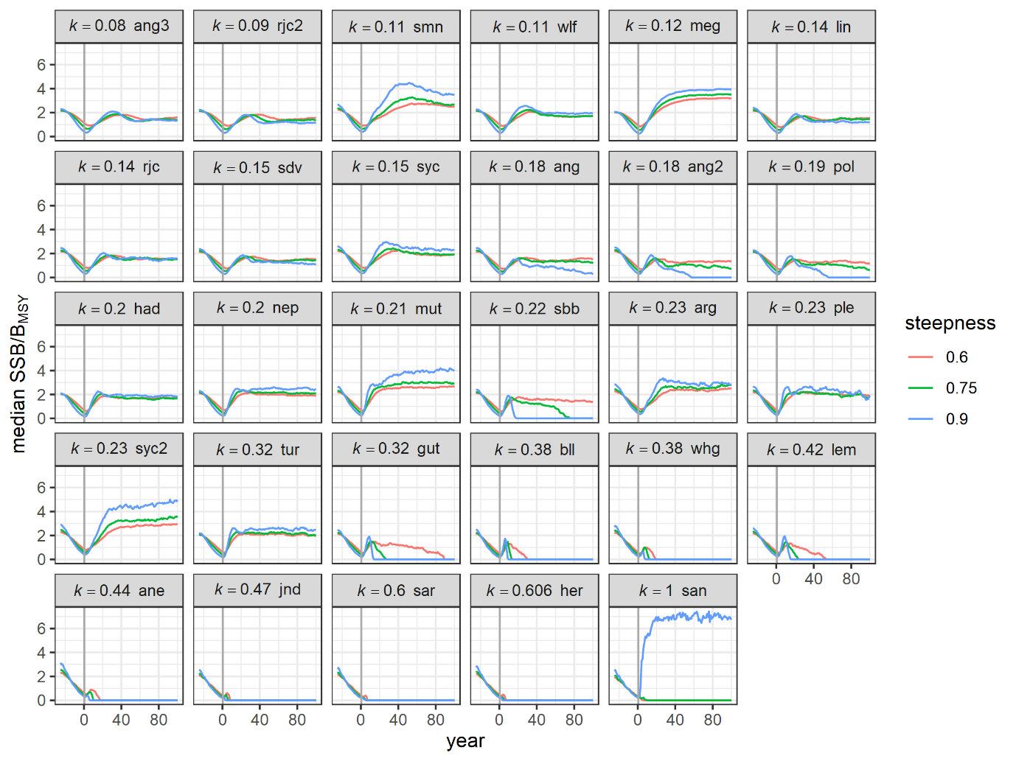

**Figure S2**. Comparison of the SSB trajectories depending on the three tested steepness values. Shown are median trajectories for SSB/BMSY for the 29 simulated stocks, sorted by von Bertalanffy growth parameter and for the one-way fishing history. The vertical grey line indicates the start of the implementation of the catch rule.

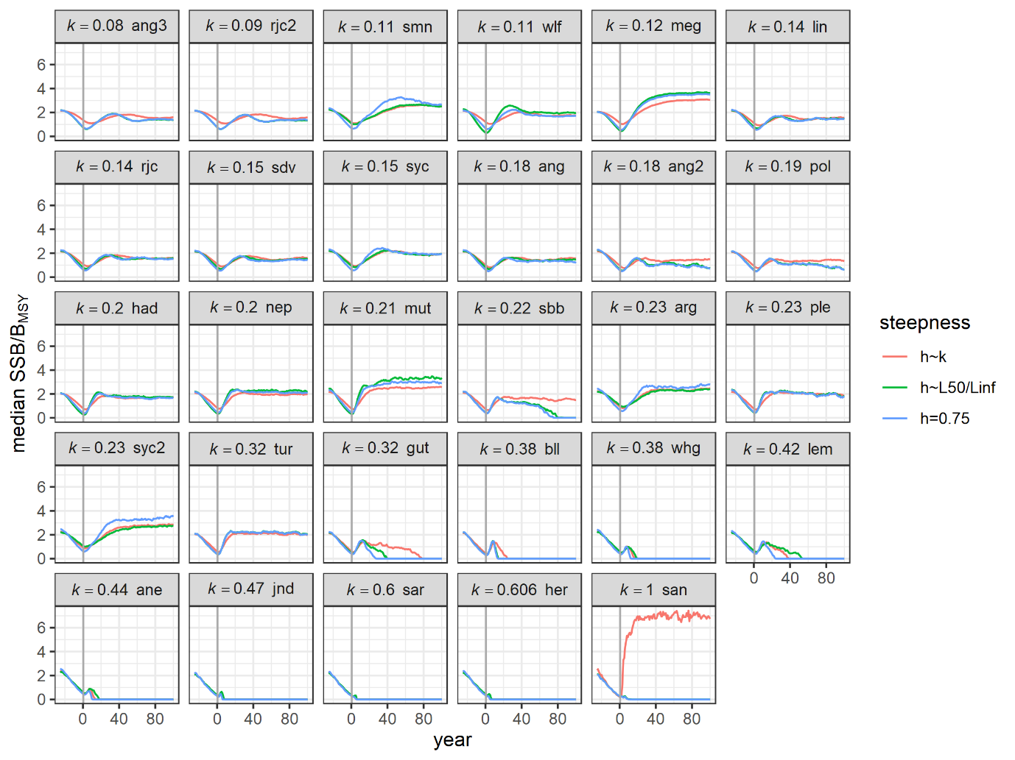

**Figure S3**. Comparison of the SSB trajectories for default steepness and scenarios imposing a link with life-history parameters. “h~k” denotes the scenario where steepness is linked to and “h~L50/Linf” uses the relationship from Wiff *et al*. (2018), see text above for more details. See Figure S2 for more details.

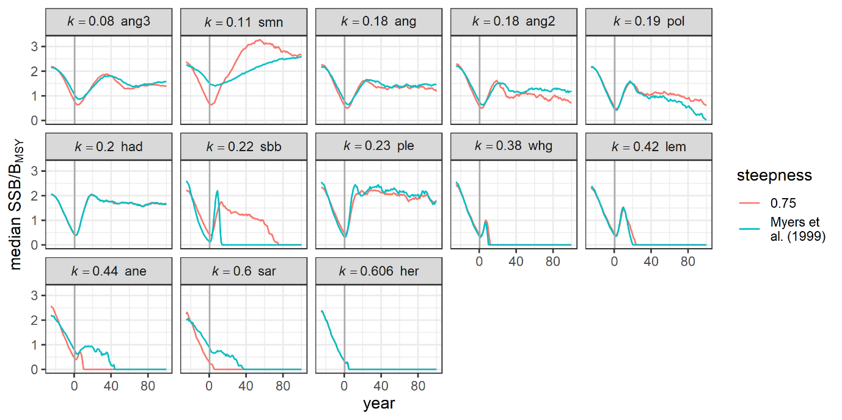

**Figure S4**. Comparison of the SSB trajectories for default steepness and the OMs where steepness values were borrowed from Myers *et al*. (1999). Shown are only the stocks for which steepness could be borrowed. See Figure S2 for more details.

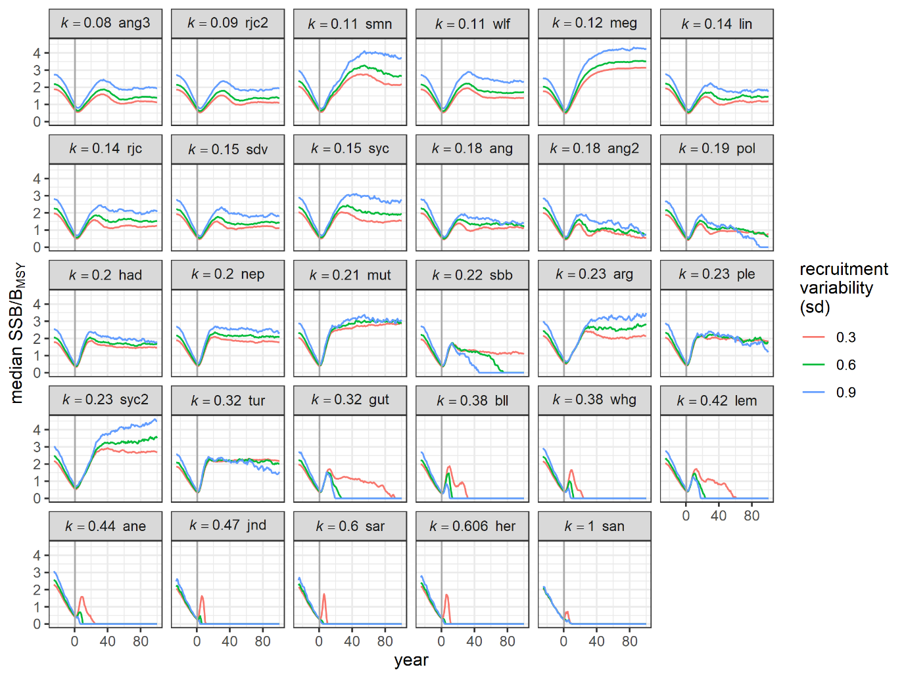

**Figure S5**. Impact of recruitment variability on SSB trajectories; sd=0.6 is the default scenario. See Figure S2 for more details.

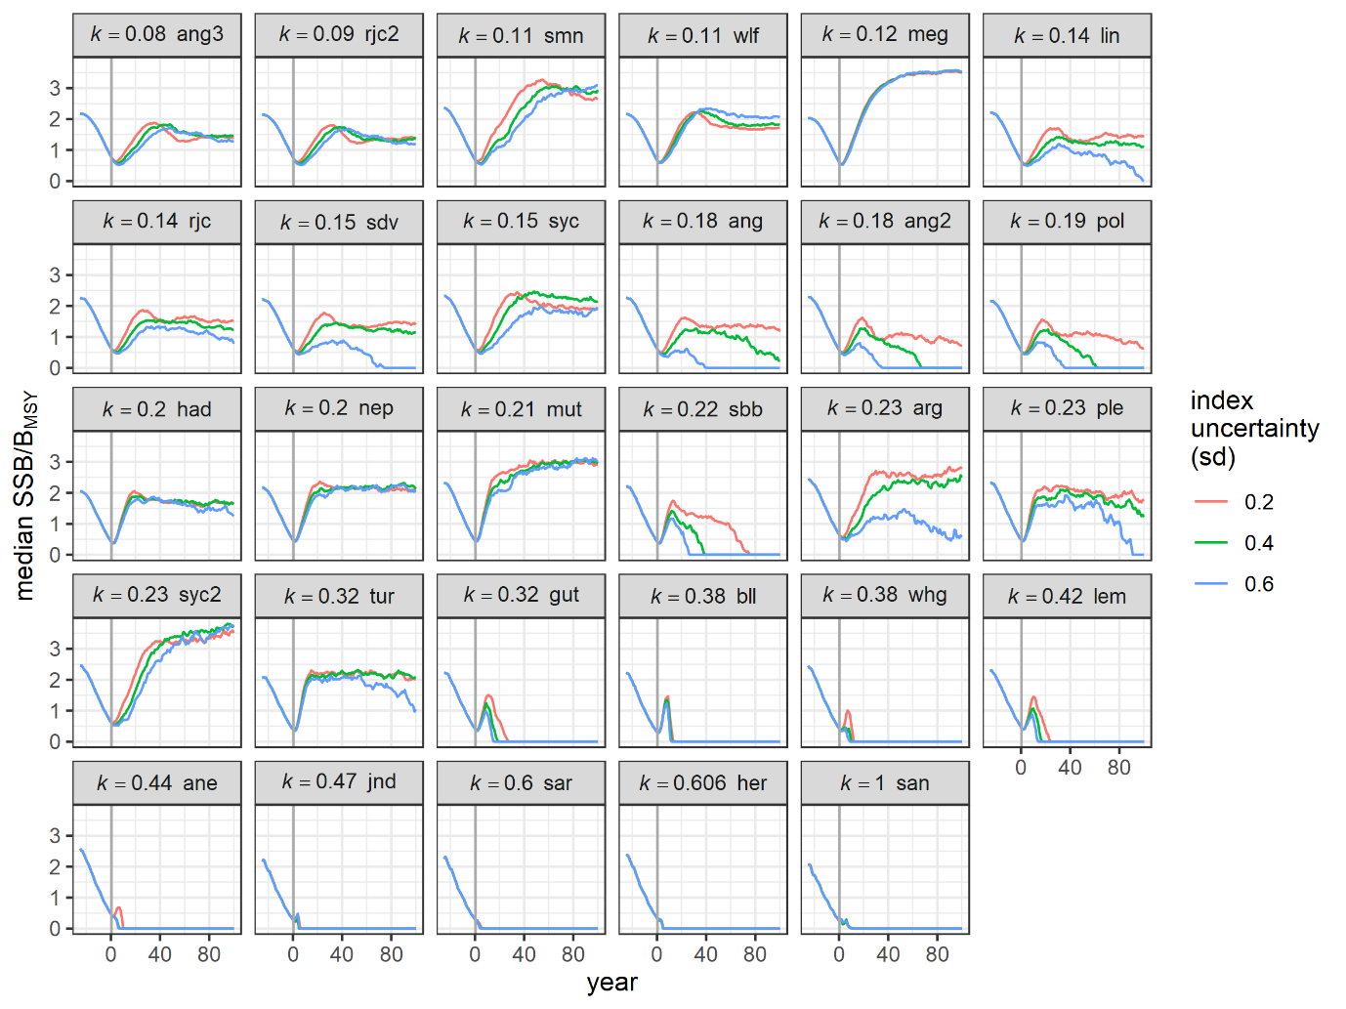

**Figure S6**. Impact of biomass index uncertainty on SSB trajectories; sd=0.2 is the default scenario. See Figure S2 for more details.

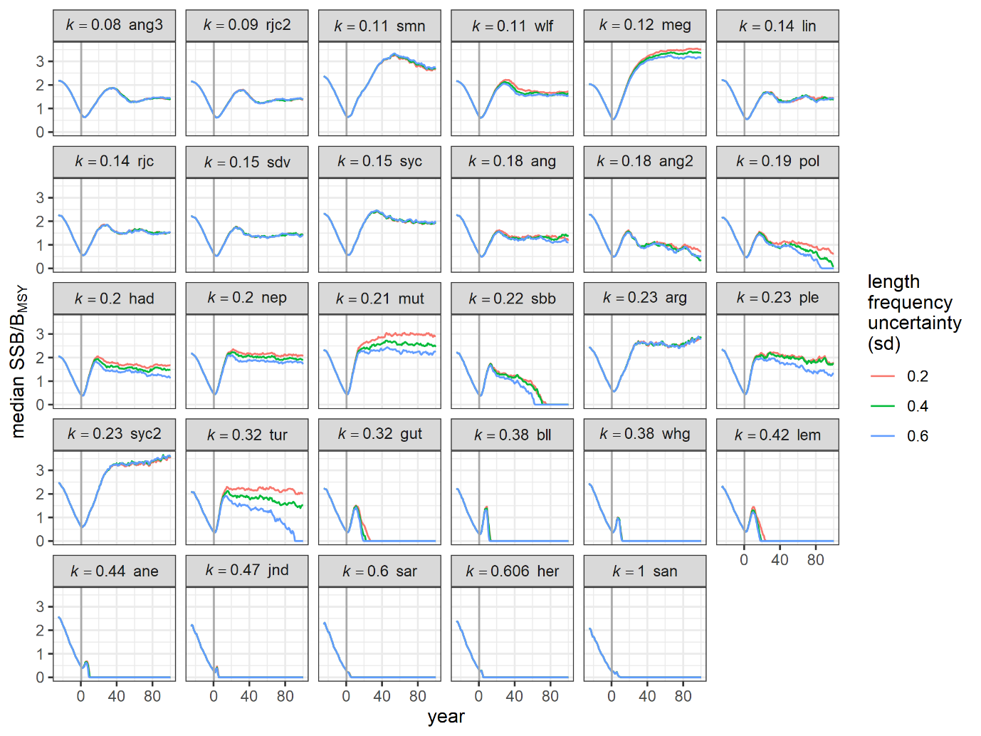

**Figure S7**. Impact of length-frequency uncertainty on SSB trajectories; sd=0.2 is the default scenario. See Figure S2 for more details.

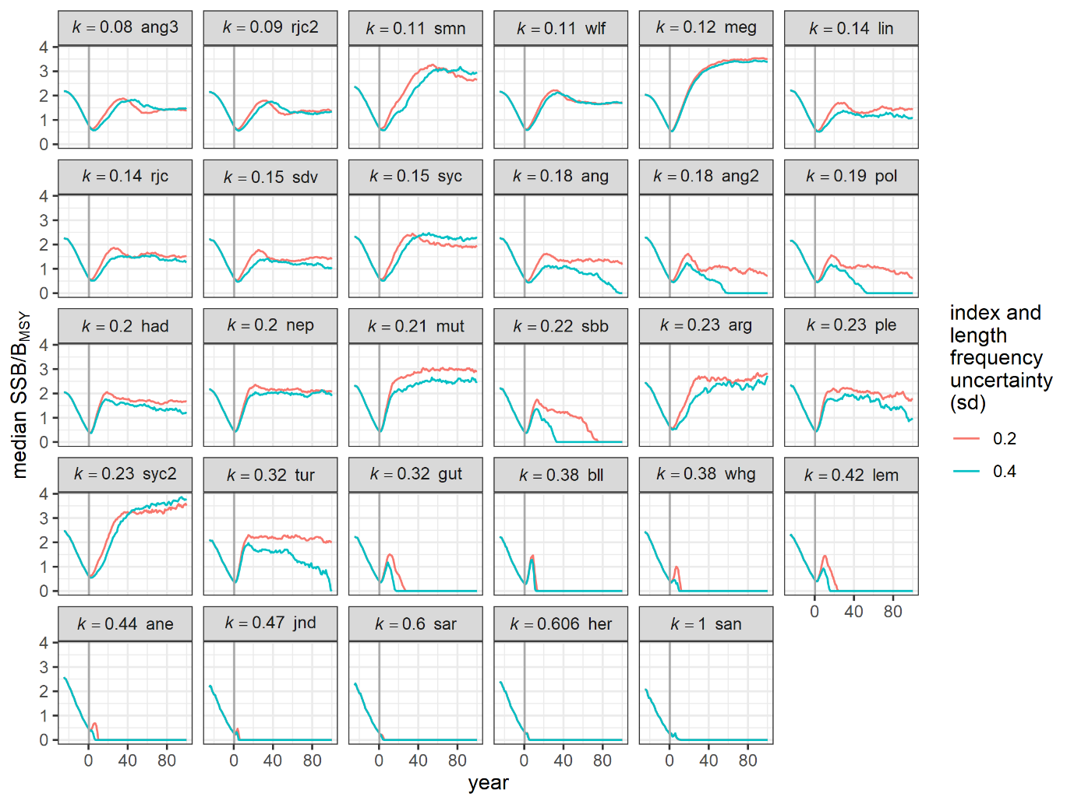

**Figure S8**. SSB trajectories for the default scenario and a scenario were the biomass index and length-frequency uncertainties were increased. See Figure S2 for more details.

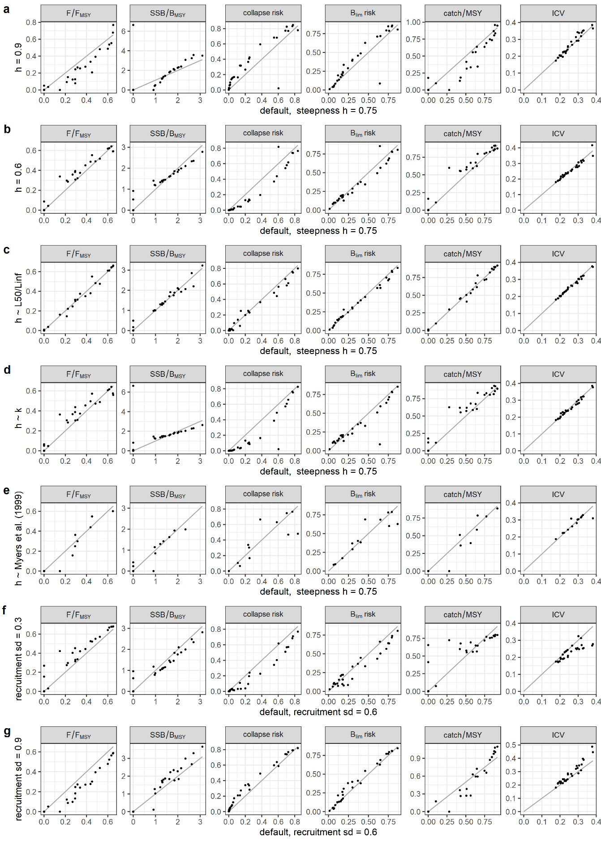

**Figure S9.** Comparison of summary statistics from the default scenario (on x-axis, columns represent different summary statistics) versus sensitivity runs with different recruitment assumptions (on y-axis, rows represent different scenarios). Each point in the plots corresponds to one of the 29 simulated stocks in the one-way fishing history. Row “e” contains fewer stocks and only the ones for which steepness values were available. The grey diagonal line is y=x.

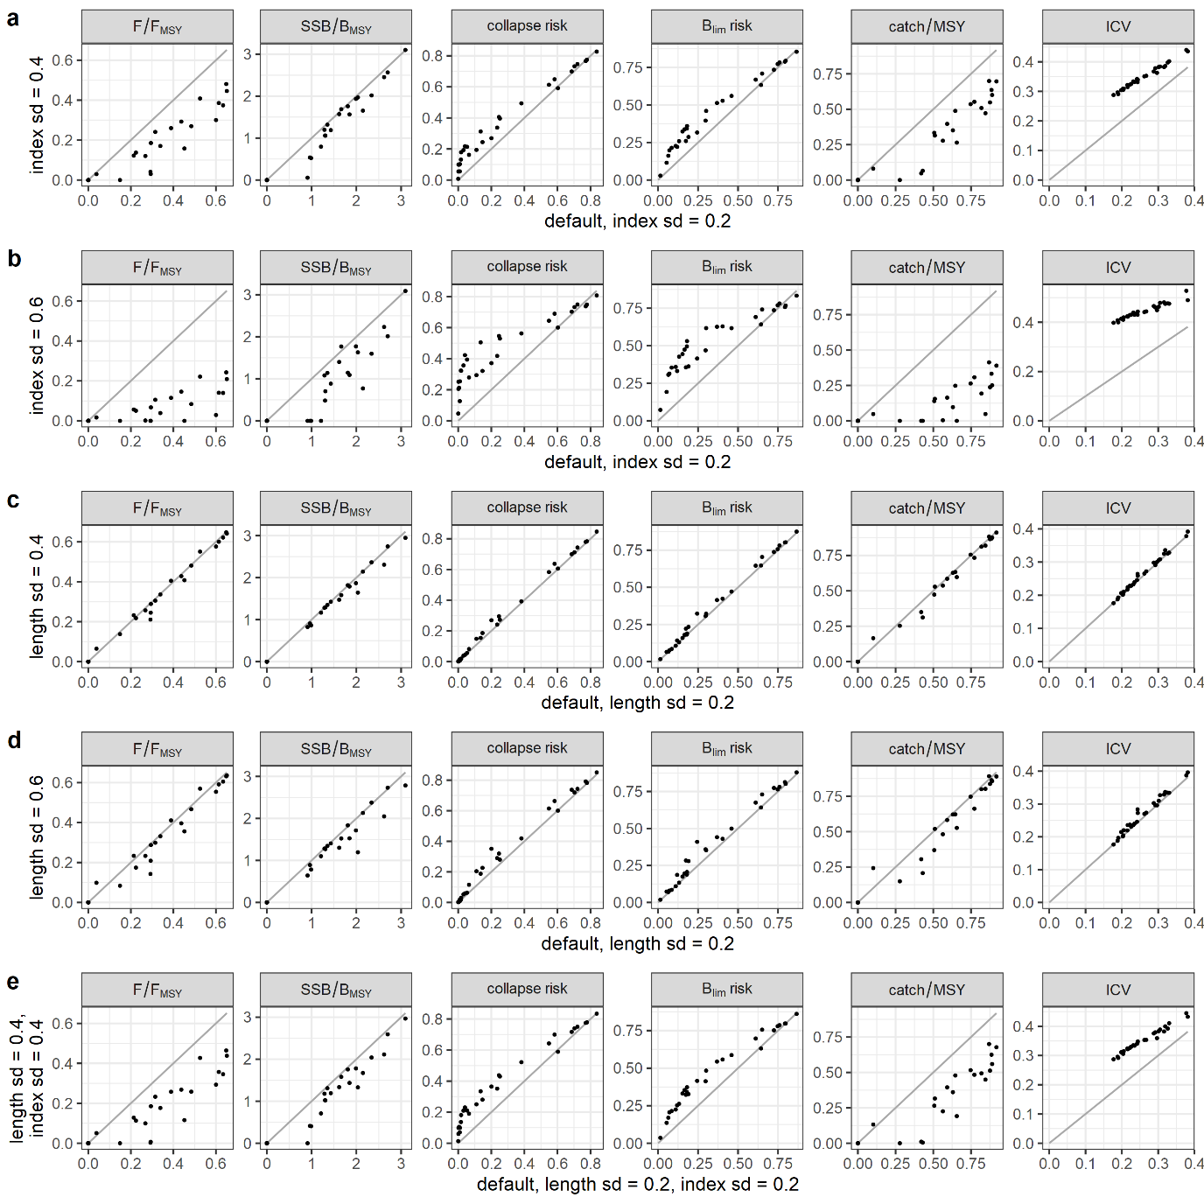

**Figure S10.** Comparison of summary statistics from the default scenario (on x-axis, columns represent different summary statistics) versus scenarios with higher index uncertainties (on y-axis, rows represent different scenarios). See Figure S9 for more details.

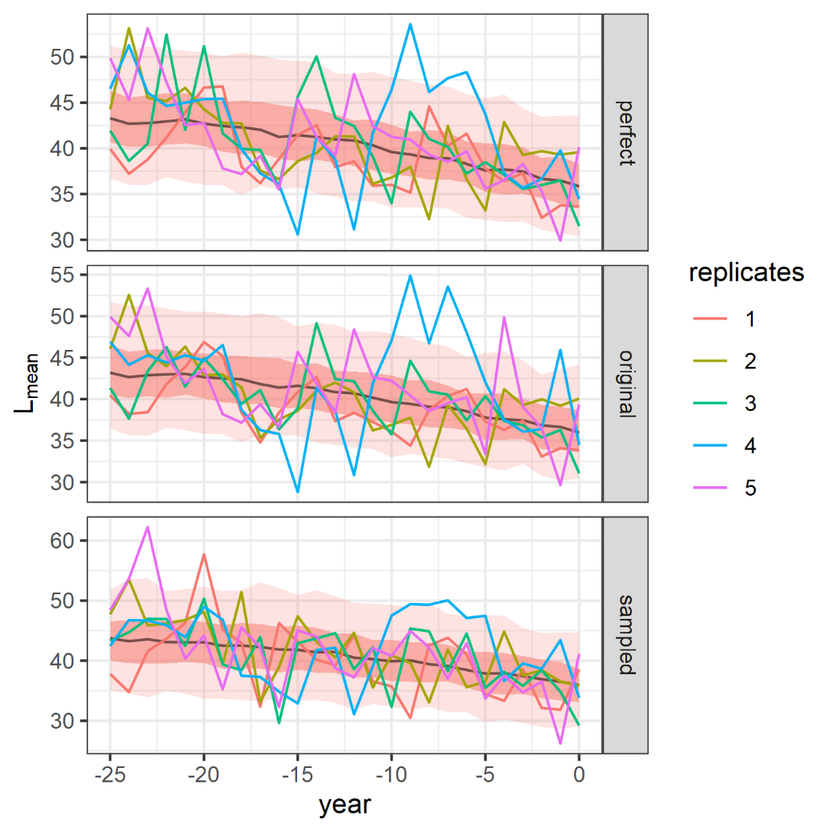

**Figure S11.** A comparison of mean lengths for one example stock, pollack, during the historical fishing period. Shown are the lengths from the inverse age-length key without observation error (top row), the approach where uncertainty is added to the numbers at length by applying an error term with sd=0.2 in log-space (middle row, the default method used in the MSE simulation), and an approach where mean length is calculated from sampling (for each year and replicate, 50 samples were randomly drawn and the mean length calculated from these samples, bottom row). The solid black line is the median, surrounded by 50 and 90% confidence intervals. The coloured curves are the first 5 (of 500) replicates.

## Discussion

The sensitivity runs detailed here support the conclusions from the main manuscript.

### Recruitment

The results of the MSE simulations are relatively insensitive to assumptions about recruitment steepness, and the division between surviving stocks with lower and collapsing stocks with higher remains.

The scenarios linking steepness to life-history parameters should be considered as purely exploratory and we do not believe they are necessarily realistic. The attempt to use realistic steepness parameters for some stocks, borrowing values from Myers *et al*. (1999), should also be treated with caution. Despite using species-specific steepness, they might not ultimately match the stocks simulated in this study. Some of the higher stocks had low steepness values according to Myers *et al.* (1999), and these might be questionable for such dynamic pelagic species.

Recruitment steepness is difficult to estimate, and steepness estimates depend on the methodology deployed and stock assessment results on which the estimation procedure is based. This is even more difficult for data-limited stocks, the subject of the present study, for which quantitative stock assessments do not exist, rendering steepness estimation procedures infeasible. The situation is exacerbated by a lack of scientifically sound relationships between steepness and life-history traits. Some studies have found links, such as Wiff *et al*. (2018), but these links entail a high uncertainty, therefore limiting their usefulness for simulation testing. Implementing the steepness link from Wiff *et al*. (2018) merely led to noise for stock trajectories and summary statistics in our simulation results. Consequently, we believe that using a single generic medium steepness value was appropriate, and the sensitivity to this steepness has been evaluated by including lower and higher levels of steepness.

The simulations were shown to be largely insensitive to different levels of recruitment variability. Despite using somewhat arbitrary levels of recruitment variability, the chosen approach was appropriate and did not generally affect our conclusions.

### Observation uncertainty

Index uncertainty did have an effect on some stocks and caused poorer performance. However, most stocks were unaffected, and the general outcome (split between lower and higher stocks) is still valid.

The uncertainty implemented for the catch length-frequency had a minor effect, because, as discussed in the main manuscript, component had only a minor contribution to the advised catch, whereas component (biomass index trend) dominated.

The quantification of the level of observation error, i.e. the difference between the observed index and the actual stock, might be considered arbitrary in the case for the data-limited stocks, because the actual stock size is unknown, and as a result the CV for observation error cannot be estimated. We therefore conducted a quick review of survey indices used within ICES for data-rich stocks (see Table S4). For these stocks, quantitative assessment results exist, and it is possible to quantify the deviation between survey biomass and assessment estimate. Several of these indices have CVs around 0.2. Even though these surveys are primarily targeting data-rich stocks, the same surveys also catch individuals from data-limited stocks, and are used in their assessments.

The mean length in the catch was simulated without sampling; however, a comparison of this approach with mean length derived from sampling revealed that the approximation did lead to very similar results, both in terms of median as well as in the spread (see Figure S11), and the approach is therefore appropriate. The main reason we did not follow the sampling approach was because it added a substantial overhead to computational time.

### Fisheries selectivity

The fisheries selectivity in the operating models used equation S7 and occurred before maturity for all stocks. This was applied to all stocks and allowed easy comparison between stocks. Alternative selectivity scenarios and sensitivity runs were considered; however, we refrained from including results here for the following reasons:

1. Consistency

Selectivity cannot be changed during the simulation and before the first implementation of the catch rule without impairing temporal consistency, because the catch rule bases the new catch advice on the previous catch, and some of the components of the catch rule also use data from previous catches.

1. Operating models

It is not possible to solely look at the effect of a different selectivity because a change in the selectivity does not only impact the catch, but results in a different operating model with different characteristics (depending on the form of the alternative selectivity) and reference points.

Alternative parametrisations for selectivity modify the historical fishing pattern because the historical fishing scenarios were based on fishing mortality and the reference point Fcrash (e.g. in the one-way fishing scenario, the fishing mortality is increased from 0.5FMSY to 0.8Fcrash within 25 years). Fcrash changes with selectivity, and the starting point of the MSE, when the catch rule is implemented the first time, is different, both in terms of absolute biomass as well as relative to BMSY. This would impair direct comparability between selectivity scenarios.

1. Catch rule components

The catch rule produces catch advice that is the result of complex interactions among the catch rule components, which use different sources of information (previous catches, catch length frequencies, a survey biomass index). Selectivity affects the components differently, and variations in selectivity could potentially lead to a mismatch of derived information. The biomass index has a selectivity different from fisheries selectivity and covers younger fish; it is therefore only indirectly influenced by changes in fisheries selectivity. However, component of the catch rule (derived from catch length frequency) is directly influenced: an alternative selectivity will lead to a different age and length distribution of the catch, and also change the length reference point LF=M. Increasingly later-occurring selectivity will lead to older fish in the catch, and the length distribution is therefore likely to be less informative due to the length growth of individuals. In an extreme case where selectivity occurs well after maturity, components and of the catch rule will use information from different parts of the stock with potentially conflicting signals.

Alternative selectivity scenarios have been trialled, but the results for some stocks were not trivial due to the reasons mentioned above and will require further analysis in future work.

### Conclusion

In conclusion, the exploration into the recruitment assumptions showed that the results and conclusions from this study are largely robust to the values of steepness and recruitment variability. In reality, steepness is notoriously difficult to estimate, and correlations with life-history information are scarce to find in empirical data, and not part of this study.

## References

Froese, R. and D. Pauly. Editors. 2019. FishBase. World Wide Web electronic publication. www.fishbase.org, (04/2019).

ICES. 2018. Report of the ICES Advisory Committee, 2018. ICES Advice 2018.

ICES. 2019. Report of the ICES Advisory Committee, 2019. ICES Advice 2019.

Jardim, E., Azevedo, M., and Brites, N. M. 2015. Harvest control rules for data limited stocks using length-based reference points and survey biomass indices. Fisheries Research, 171: 12–19.

Myers, R. A., Bowen, K. G., and Barrowman, N. J. 1999. Maximum reproductive rate of fish at low population sizes. Canadian Journal of Fisheries and Aquatic Sciences, 56: 2404–2419.

Wiff, R., Flores, A., Neira, S., and Caneco, B. 2018. Estimating steepness of the stock-recruitment relationship in Chilean fish stocks using meta-analysis. Fisheries Research, 200: 61–67.